# Next Generation Smart Stick For Blind People Using Assistive Technology

1*Mangesh Balpande, 2Shruti Kothawade, 3Gaurav Pawar, 4Mahek Sayyad, 5Jay Patil

*1,2,3,4,5 SVKM’s Institute of Technology, Dhule, 424001, India*

# 

**Abstract**

The development of a Smart Guidance Stick, an innovative technology solution aimed to increase mobility and independence of people with visual impairments, is discussed in this project. The Stick incorporates sensors, microcontrollers, communication tools, and new features such as real-time smart support and emergency contacts. Its goal is to offer visually impaired persons the confidence to navigate unfamiliar surroundings, detect obstacles and get precise instructions via audio guidance. It also has an emergency alert system in case of an emergency. This innovation addresses barriers faced by the blind and visually challenged community by combining sensor technology, algorithms, and communication tools to give greater navigation and autonomy. This work demonstrates how hardware features and components can be successfully integrated.

*Keywords: Audio Guidance, Arduino Uno, Navigation, Obstacle Detection, Sensors, Visual Impairments*

**1. Introduction**

This research paper goes into the development of a new assistive gadget, the Smart Guidance Stick, which aims to transform the mobility of people with visual impairments. Navigating unfamiliar areas presents difficulties for the blind, and current methods lack precision in obstacle recognition. To overcome this, our product combines machine learning,[3] artificial intelligence, and GPS technology. The Smart direction Stick not only identifies impediments in real time but also provides exact voice direction, allowing visually impaired people to walk with confidence. With an emergency alarm system built in, the device improves safety in crucial situations, making it a game-changing tool for fostering autonomy and independence among the visually impaired.

At the core of this development is a precise combination of sensor technologies, complex algorithms, and communication tools. The Smart Guidance Stick overcomes prior limits by offering rapid obstacle recognition, haptic feedback, and environmental data.[1] The work not only helps to advance assistive technologies but also highlights the potential of comprehensive tools in improving the daily lives of people with visual impairments. In essence, this article investigates the Smart Guidance Stick's potential position as a symbol of progress, providing a comprehensive and powerful solution to improve the general well-being and independence of the visually impaired community.

The project aims to close the gap in current assistive technologies for the visually impaired by offering the Smart Guidance Stick as a multifaceted solution. Beyond obstacle recognition and navigation help, the device includes an emergency warning system for added safety, ensuring a quick response in unexpected situations.[6] The Smart Guidance Stick is not just a technological marvel but also a symbol of inclusivity, intended to empower people with visual impairments to confidently explore and interact with their surroundings. By integrating cutting-edge technology with user-centric design, this work envisions a future in which the visually handicapped may explore the world with greater autonomy, fostering independence and breaking down accessibility obstacles.[4] The Smart Guidance Stick is not simply a tool; it's a step toward a more inclusive and accessible future.

**2. Related work**

The prevalence of visual disability has surged to 285 million, with 39 million facing complete blindness and 246 million experiencing low vision, often associated with age. Among the completely blind, 15% are under 50 years old, emphasizing the need for improved assistance systems. Despite recent inventions, existing assisting devices fall short, lacking both range and comprehensive features.[9] This project aims to fill this gap by developing a system that offers blind individuals assistance against obstacles, providing real time alerts for enhanced mobility without reliance on traditional aids like sticks.[13] The goal is to empower visually impaired individuals to navigate the world more easily and lead better lives.

In the realm of assistive technologies for the visually impaired, various research initiatives have explored smart navigation aids. Some studies focus on integrating ultrasonic sensors into mobility aids, akin to the proposed design, for real-time obstacle detection. Additionally, research emphasizes the use of GPS for location tracking and route planning, aligning with efforts to enhance navigation in unfamiliar areas.[5] The literature also explores alternative alert mechanisms, like vibration motors, in noisy environments. Communication features, including sending SMS messages with location information, have been integrated to improve accessibility.[14] The proposed design aligns with this research, offering a cost-effective and user-friendly solution to enhance the independence and safety of blind and visually impaired individuals.

The research paper suggests an innovative and cost-effective study that provides a smart stick for visually impaired individuals has problems. It doesn't provide enough technical information and practical insights; it doesn't clarify how sensors like ultrasonic and light sensors are connected to the buzzer and LED lights, making it difficult to judge how well it would work in real life.[1] The system's effectiveness in addressing the challenges faced by the visually impaired is unclear.[7] It raises concerns, including insufficient battery management details, potential discomfort due to stick weight, and the need for seamless component integration. To ensure real-world viability, addressing these issues is essential.[8]

A smart stick for the visually impaired using ultrasonic sensors can detect obstacles. The paper lacks essential technical details related to cost effectiveness and integration details. Addressing these details is essential to ensure that the device is viable in the real world.[9] Future work should focus on refining the system, conducting extensive field testing, addressing privacy and security concerns, and ensuring affordability and accessibility for a wide range of users.[2] Addressing these issues, conducting extensive field testing, and ensuring that the stick meets the diverse needs of visually impaired individuals in various environments is important.[3].

The aim is to improve the daily lives of visually impaired individuals by developing a smart gadget. Visual loss poses challenges in basic tasks, and existing solutions often lack the necessary technological support. The project utilizes artificial intelligence and image processing to enable the gadget to recognize faces, objects, and colors. Notifications, in the form of vibrations or sounds, inform users about their surroundings.[15] The study involves a survey of local visually impaired residents, contributing valuable insights. Overall, this research seeks to make a meaningful impact on healthcare by providing practical assistance to blind individuals through the application of smart technology.

The visually impaired navigate a variety of surfaces and obstacles, but they are unable to fix the destination navigation problem. The structure and main functions of Smart Sticks, a tool for blind people to navigate, are illustrated in this paper.[10] Nevertheless, they chose not to charge for it because the cost was so high.[9] In this work, a smart assistive technology is developed and put into use to help blind or visually impaired people safely navigate stairs, water, barriers, and other everyday hurdles. Still, the device is unable to offer a virtual assistant.[1]

Research in assistive technologies for the visually impaired has explored solutions beyond traditional white canes, given their limitations in obstacle detection. Innovations include integrating sensors like ultrasonics and infrared into mobility aids for real-time obstacle detection. Some projects have focused on smart canes with features such as vibration motors for alerts.[7] Addressing stair navigation challenges, researchers have incorporated stair-detection functionalities. The integration of GPS and GSM modules for location tracking has been explored for enhanced safety. Nguyen et al.'s proposed smart blind stick contributes to this field by combining obstacle detection, stair alarms, and location tracking in an affordable design.[11]

The [12] study introduces an autonomous smart stick framework for visually impaired individuals, addressing various challenges they face. The framework employs advanced sensing mechanisms, wireless communication, and GPS/GSM for location tracking. Features include obstacle detection, detailed information dissemination, buzzer alerts, and multimedia messaging.[10] The stick's foldability enhances convenience for users, making it a robust and comprehensive solution for improved navigation and safety.

The linked work focuses on creating a smart cane for visually challenged people, complete with ultrasonic sensors for obstacle detection and an ESP-32 camera module for capturing images of moving objects and people.[16] This is consistent with previous research on sensor-based navigation aids and assistive gadgets for the visually impaired, which aims to improve mobility and safety.

**3. Proposed work**

1. *System Overview:*

Figure 1 depicts a flowchart of the system, illustrating how the Smart Guidance Stick is a unique solution specifically designed to enable rapid and effective responses in emergency situations. it is supported by a strong framework for checking hardware integrity and algorithmic efficacy. Its adaptive response mechanism is a sophisticated layer of intelligence that can dynamically analyze and assess potential risks while also adeptly recognizing user requests for tailored assistance or autonomously initiating emergency protocols as needed.

In barrier detection settings, the system takes advantage of real-time imaging technology to capture and evaluate intricate information about the surrounding environment, allowing for proactive danger assessment. This comprehensive situational awareness provides users with critical information, allowing for educated decision-making and prompt, decisive action when confronted with imminent hazards.

Beyond its fundamental functions, the Smart Guidance Stick effortlessly interacts with navigation systems and includes easy user interaction capabilities, increasing agility and allowing users to navigate different situations with confidence and ease. This technological synergy not only promotes empowerment, but also acts as a key lifeline at times of crisis, providing reassurance and support when it is most needed. Importantly, the gadget works effortlessly under normal circumstances, keeping watchful and ready to respond at a moment's notice until either deactivated or prompted by user-initiated emergency warnings. This constant commitment to continuous operation demonstrates the device's unflinching devotion to user safety, offering outstanding accuracy, adaptability, and response across a wide range of emergency conditions.

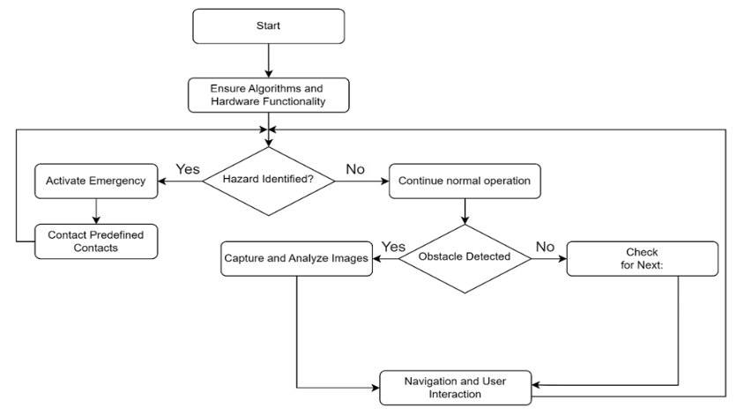

*Fig.1: Flow chart of system*

1. *Methodology:*

The proposed Smart Stick project proposes to assist visually impaired people by combining ultrasonic, laser, and solar sensors with a virtual assistant and emergency contact functions.[11] Despite its potential benefits, this project faces numerous operational obstacles and lacks critical technical information. Concerns concerning the system's real-world effectiveness include a lack of information on sensor connectivity, battery management, and discomfort caused by stick weight. Furthermore, the lack of practical insights and cost-effectiveness information prevents a thorough grasp of the project's potential.

To address these concerns, future work should focus on improving obstacle identification, undertaking thorough field testing, and guaranteeing seamless component interaction. Furthermore, the inclusion of water sensors, GPS, and GSM modules for water detection and location monitoring adds another level of capability. The use of artificial intelligence, machine learning, deep learning, convolutional neural networks, and the Internet of Things emphasizes the project’s [14] technological complexities. However, assuring affordability, addressing privacy and security concerns, and satisfying the varying demands of visually impaired people in various settings are critical to the project's success in real-world applications.

**I. Algorithms Used:**

1. Linear Algorithm:

**d = v⋅t**, (Simple product of constant velocity and reaction time).

1. Logistic Regression:

**P (y = 0 ∣ x) = 1−P (y = 1∣ x),** (Probability estimation using a logistic function of weighted input features).

1. ML Algorithms:

**Model = Train (X, y),** (Learning complex patterns from labeled sensor data to classify obstacles).

1. Computer Vision Algorithms:

**CNN = Train (Images, Labels)**, (Hierarchical feature extraction and classification from visual data).

1. Reinforcement Learning:

**Policy = Learn (Environment),** (Agent learns to navigate through interaction the environment to maximize long-term rewards).

1. Kalman Filters:

**Estimation=Update (Measurement, Model)**, Fusing noisy sensor data with a dynamic model to estimate obstacle positions).

Linear and logistic regression, machine learning (SVM, Random Forests, Neural Networks), computer vision (CNNs), reinforcement learning, and Kalman Filters are all important methods in the development of a smart guidance stick for the visually handicapped. These algorithms improve [9] obstacle detection and navigation capabilities by ranging from simple to sophisticated approaches, adapting to different environments, analyzing visual data for precise obstacle identification, optimizing navigation strategies, and accurately estimating obstacle positions for reliable guidance.

**II. Working:**

1. YOLO Object Detector:

YOLO, a convolutional neural network illustrated in figure 2, identifies objects but creates practical and usability concerns around smart walking stick concepts.[6] RCNNs and their extensions, such as Fast RCNN and Faster RCNN, have been used for one-shot object detection and learning.

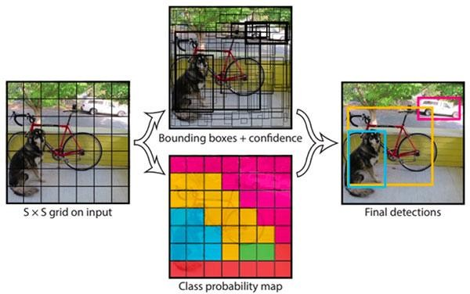

*Fig.2: Yolo Object detector illustration*

1. YOLO working:

YOLO works in two stages. First, it detects regions of interest in an image and then classifies them using a convolutional neural network.[7] It gives probabilities and bounds to each zone, allowing for accurate classification based on the algorithm's confidence levels.

1. COCO Dataset:

The COCO dataset, which was utilized for YOLO object recognition, contains labeled bounding boxes for 80 item categories. YOLO divides photos into grids and calculates box boundaries, class probabilities, and objectness scores for each cell.[5] This fast approach allows for the real-time identification and classification of many objects in a variety of applications.

1. Distance:

The ultrasonic sensor depicted in figure 3 measures a distance by emitting a 45000 Hz wave from pin 17, which bounces back upon encountering an obstacle.[10] By calculating the time delay between emission and reception, accurate distance measurements are provided to the user.

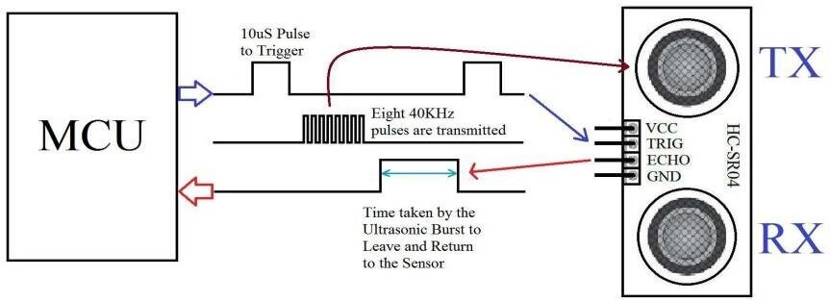

*Fig.3: Ultrasonic Sensor*

The sensor can detect objects in range of 2cm to 300 cm. The distance is calculated by the formula given below.

Formula: 17200 * time = distance of sensor

In this, we propose a method allowing visually impaired persons to use a stick as a secondary eye. The stick has various hardware components, including the following:

* Arduino UNO
* Camera
* Ultrasonic and Water sensor
* Earphones
* Emergency System using GMS & GPS
* Battery

It will use a camera to take photographs of the user's surroundings, and the YOLO algorithm will be used to recognize and identify all objects in the captured images. Once objects are spotted, a sensor built into the system calculates the distance to each one. This distance information is then communicated to the user via an earbud or wired earphone, giving them real-time aural input on the items around them.[12] By combining optical object detection, distance calculation, and aural input, the system attempts to improve the user's awareness of their surroundings, assisting visually impaired users with navigation and obstacle avoidance.

1. ***Architecture****:*

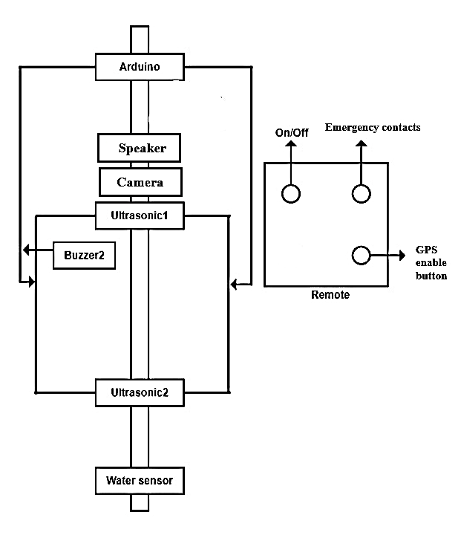

## *Fig.4: System Architecture*

Figure 4 shows the proposed system architecture [8] for assisting visually impaired individuals, involving a streamlined process.

1. **Image Classification:** The system starts by classifying images using an artificial intelligence-based classification algorithm to understand the content.
2. **Sensor Data Reading:** Data from sensors, such as ultrasonic or infrared sensors, is then collected to gather information about the user's surroundings.
3. **Arduino Processing**: The collected sensor data is processed by an Arduino microcontroller, which analyzes the input and makes decisions based on the identified information.
4. **Earphone Feedback**: The final step provides real-time feedback to the visually impaired user through earphones, conveying object details and relevant environmental information obtained from processed sensor data.[5] The specific techniques for image classification and sensor processing depend on the chosen technology and methods within the system.

***D. Circuit Diagram:***

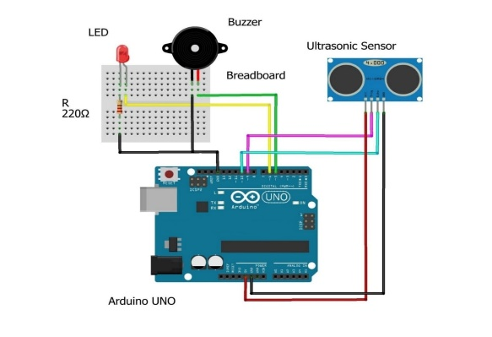

*Fig.5: Circuit Connection Flow*

In Figure 5, the circuit connection flow demonstrates the utilization of an HC-SR04 Ultrasonic sensor interfaced with an Arduino board., enhancing navigation for the visually impaired. The Ultrasonic sensor, responsible for scanning the path, connects to the Arduino's digital pins for triggering and receiving echo signals. Upon detecting an obstacle, the buzzer activates, emitting a beeping sound. Simultaneously, the LED lights up, alerting the user.[7] The Arduino's serial monitor displays real-time distance values in centimeters, aiding the blind person in gauging their surroundings. The seamless integration of the sensor, buzzer, and LED creates an intuitive system, empowering the visually impaired to navigate safely by interpreting the audible and visual cues provided by the Smart Guidance Stick.[2]

**4. Result**

1. **General Approach:**

The model produced the following results, as seen in figure 6. The general method used here is that digital formatted images, represented as pixels, are stored from the camera on the stick. As seen in the illustration, the YOLO algorithm reads the image data as input.[6] Twelve distinct classes of objects—a dog, a bicycle, and a car—are identified by CNN as being a part of YOLO in a single image. Based on the accuracy of these classes' presence, the output of YOLO is recorded in text format in the internal memory of the Arduino Pi. The Arduino Pi turns this text into audio, which is then sent to the blind person as speech. The stick's ultrasonic sensor measures the distance between the blind stick and the object; the blind person is also informed of this distance.[5] The general method of reviewing the outcomes is determining how accurate and effective the characteristics of our smart walking stick are. This includes examining the accuracy of object identification in real-time, obstacle awareness via haptic feedback, and GPS-based navigation dependability.

1. **Yolo Object detection output:**

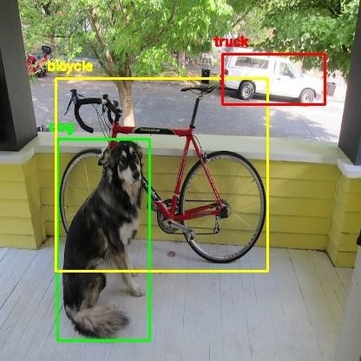

*Fig.6: Yolo object detector output*

**C. Real Results attained:**

In Figure 7, the image is transmitted from the camera to the Arduino, where the YOLO algorithm uses its learned examples to classify it. The image is then displayed on the console, along with the distance of the object that has been classified from the blind person, on the screen**.** [7]

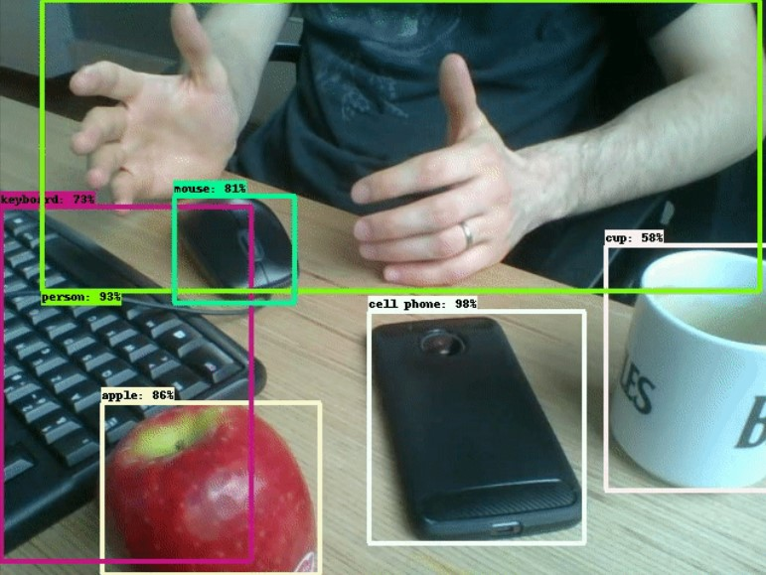

*Fig.7: output of Object detector*

This type of outcome is primarily utilized in the development stage to test the stick and train it with an increasing number of items in order to improve the stick’s performance.[7] The image above was taken with the camera that had been set up on the blind stick, and it was then classified using the YOLO method. Based on its training objects, YOLO categorizes a single object into classes and gives auditory feedback of correctness such as a keyboard, mouse, person, apple, cell phone, or cup. The system also determines the number of these objects. Based on the items it has been trained on, YOLO separates a single into classes of objects, such as the printer, keyboard, and console. The performance of the above figure (figure 7) is depicted in the figure 8.

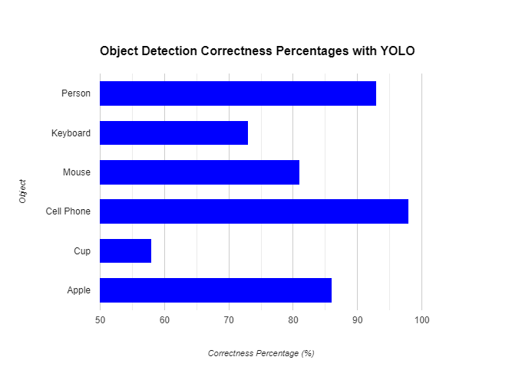

*Fig. 8: Accuracy of detecting obstacles*

**D. Audio output to blind person:**

In figure 9, when a blind person is walking along a pathway, if there are any obstacles in their path, a camera takes a picture and sends it to the Arduino. The YOLO uses its trained examples to classify the image and determines its corresponding name, such as "person", "vehicle", "bike", "water", etc. Textual images are converted to speech by the Arduino and heard by the blind person through a headphone.[5] The blind person is also informed of the object's precise nature and distance from them by hearing the distance between the object, which is determined by an ultrasonic sensor and themselves.

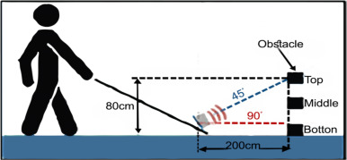

*Fig.9: output of Object detector*

Our approach for measuring distance functions remarkably like human vision. Our intelligent walking stick uses cutting-edge technology to measure the distance between the user and things that are detected, simulating human senses' subtle perception of space and environment.[10] By improving the user's situational awareness, this feature allows for an environment interaction that closely resembles what it is like to be a human, as displayed in fig.9.

**E. Emergency System:**

An essential component of our study methodology is the installation of an emergency system, which embodies our steadfast dedication to user-centric design and safety in the context of assistive technology. The technology is simple to activate with three touches, making it accessible in high-stress situations.[13] Our emergency system stands out due to its sophisticated contextual intelligence, which goes beyond standard distress signals to provide precise location information. This turns our smart walking stick from a purely reactive gadget into a proactive safety companion.

Our emergency system is superior because of its two-way communication. In addition to alerting emergency contacts to the presence of a crisis, it also strategically communicates position and urgency, allowing for accurate response. This creates a vital conduit between the user and their network of support, promoting a deep sense of safety and independence. As we lead the way in assistive technology, our smart walking stick's emergency system is more than just a tool—rather, it represents a trustworthy partner in the quest for increased safety and self-sufficiency for those who are visually impaired.[15] Within the context of our study paper, the emergency system stands out as a pillar that best represents our commitment to closing the gap that exists between technology and human welfare. It transforms the intelligent walking stick from a feature into a reliable friend who is ready to take immediate action should things get serious.

**6. Conclusion**

An important step in enhancing the independence and mobility of those with vision impairments is the Smart Guidance Stick. This technology easily integrates sensors, microcontrollers, communication tools, and novel features like real-time smart support and emergency connections to tackle significant problems for the blind and visually impaired. The Stick allows users to comfortably explore unfamiliar areas, detect impediments, and get accurate auditory assistance, resulting in increased autonomy. The addition of an emergency alert system ensures users' safety in crucial situations. This Work emphasizes the successful integration of hardware components and features, indicating a positive step toward removing barriers for the visually impaired.

**Future Scope**

Furthermore, the Smart Guidance Stick might be configured to communicate with smart city infrastructure, resulting in a seamless and integrated navigating experience. The potential for global effect is significant, and efforts should be made to make this technology available to a larger populace. As society strives for greater inclusivity, the Smart Guidance Stick serves as a symbol of progress, demonstrating how innovation can break down barriers and enable people with visual impairments to live more independent and meaningful lives.

**References:**

[1] Md. Mostofa Shah, Md. Nasfikur R. Khan, Md. Raihan Ali Khan, Md. Mokarrom Hossain Plabon, M. Abdur Razzak, "A Cost- Effective Smart Walking Stick for Visually Impaired People",2021 6th International Conference on Communication and Electronics Systems (ICCES-2021), IEEE, 2021.

[2] Mariam M. Bastaki, Abrar A. Sobuh, Noor F. Suhaiban, Eqab R. Almajali, "Design and implementation of a Vision Stick with Outdoor/Indoor Guiding Systems and Smart Detection and Emergency Features", IEEE, 2023.

[3] Prashik Chavan, Kartikesh Ambavade, Siddhesh Bajad, Rohan Chaudhari, Roshani Raut, "Smart Blind Stick,"2022 6th International Conference On Computing, Communication, Control And Automation (ICCUBEA), IEEE, 2022.

[4] Md Ashrafuzzaman, Suman Saha, Neser Uddin, Pranto Kumar Saha, Sojib Hossen, Kamruddin Nur, "Design and Development of a Low-cost Smart Stick for Visually Impaired People,"2021 International Conference on Science & Contemporary Technologies (ICSCT), IEEE, 2021.

[5] Mukesh Prasad Agrawal, Atma Ram Gupta, "Smart Stick for the Blind and Visually Impaired People,"2nd International Conference on Inventive Communication and Computational Technologies (ICICCT 2018), IEEE, 2018.

[6] Khadega Ahmed Mohammed Gubran, Muna Rabea Salim Hanien, Mohammed Salem Farag BinWahlan, Samir Salem Al-Bawri, "Ultrasonic Smart Stick Vision-Based EyeTech Digital System for Movement Tracking,"2022 IEEE International RF and Microwave Conference (RFM), IEEE, 2022.

[7] Prasad Ramachandra Mavarkar, Zarinabegam K Mundarg, "Real Time Smart Bind Stick using Artificial Intelligence”, Indian Journal of Artificial Intelligence and Neural Networking (IJAINN) ISSN: 2582-7626 (Online), Volume-1 Issue-1 December 2020

[8] Himanshu Sharma, Meenakshi Tripathi, Amit Kumar, Manoj Singh Gaur, "Embedded Assistive Stick for Visually Impaired Persons,"IEEE - 43488,9th ICCCNT 2018, IEEE, 2018.

[9] Vyash Natarajan, Yogeshwaran M, Dr. Aroul Canessane M.E., Ph.D., "IoT based Smart Stick with Automated Obstacle Detector for Blind People, “Sixth International Conference on Trends in Electronics and Informatics (ICOEI 2022), IEEE, 2022.

[10] Naiwrita Dey, Ankita Paul, Pritha Ghosh, Chandrama Mukherjee, Rahul De, Sohini Dey, "Ultrasonic Sensor Based Smart Blind Stick, “Proceeding of 2018 IEEE International Conference on Current Trends toward Converging Technologies, IEEE

[11] Hung Quoc Nguyen, Anh Hoang Lan Duong, Man Dinh Vu, Thinh Quoc Dinh & Hoan Thanh Ngo, "Smart Blind Stick for Visually Impaired People”, Springer 2022, Hoan Thanh Ngo in 8th International Conference on the Development of Biomedical Engineering in Vietnam

[12] Tesfahunegn Minwuyelet Mengistu, Ayalew Belay Habtie, Fikreselam Gared Mengistu in Advances of Science and Technology, "Design and Development of an Autonomous Smart Stick Framework for Assisting Visually Impaired People”, Springer conference paper 2022

[13] Maneesh Vishwakarma, Harivans Pratap Singh, Nitin Kumar & Manan Arora, "The Need of Smart Guidance Systems for Blind People in the World”, Springer conference paper 2020

[14] Safaa Najah Saud, Lilysuriazna Raya, Muhammad Irsyad Abdullah & Mohd Zaki Awg Isa, "Smart Navigation Aids for Blind and Vision Impairment People”, Springer conference paper 2021

[15] S Barathi Kanna, T R Ganesh Kumar, C Niranjan, S Prashanth, J Rolant Gini, M.E. Harikumar, "Low-Cost Smart Navigation System for the Blind",2021 7th International Conference on Advanced Computing and Communication Systems (ICACCS), Springer

[16] T Lavanya Narayani, Sivapalanirajan. M, Keerthika. B, Ananthi. M, Arunarani. M,"Design of Smart Cane with integrated camera module for visually impaired people"2021 International Conference on Artificial Intelligence and Smart Systems (ICAIS), IEEE